AI ASS 14.1
Name:B.Sanjana
H.T.N0:2303A52306
Batch:43
Task1:portfolio website
Prompt:
Create a modern personal portfolio website using HTML, CSS, and JavaScript.
Include sections for About Me, Projects, and Contact.
Use a clean color palette and suggest suitable typography.
Make the layout responsive using Flexbox and Grid.
Add smooth scrolling navigation for better user experience.

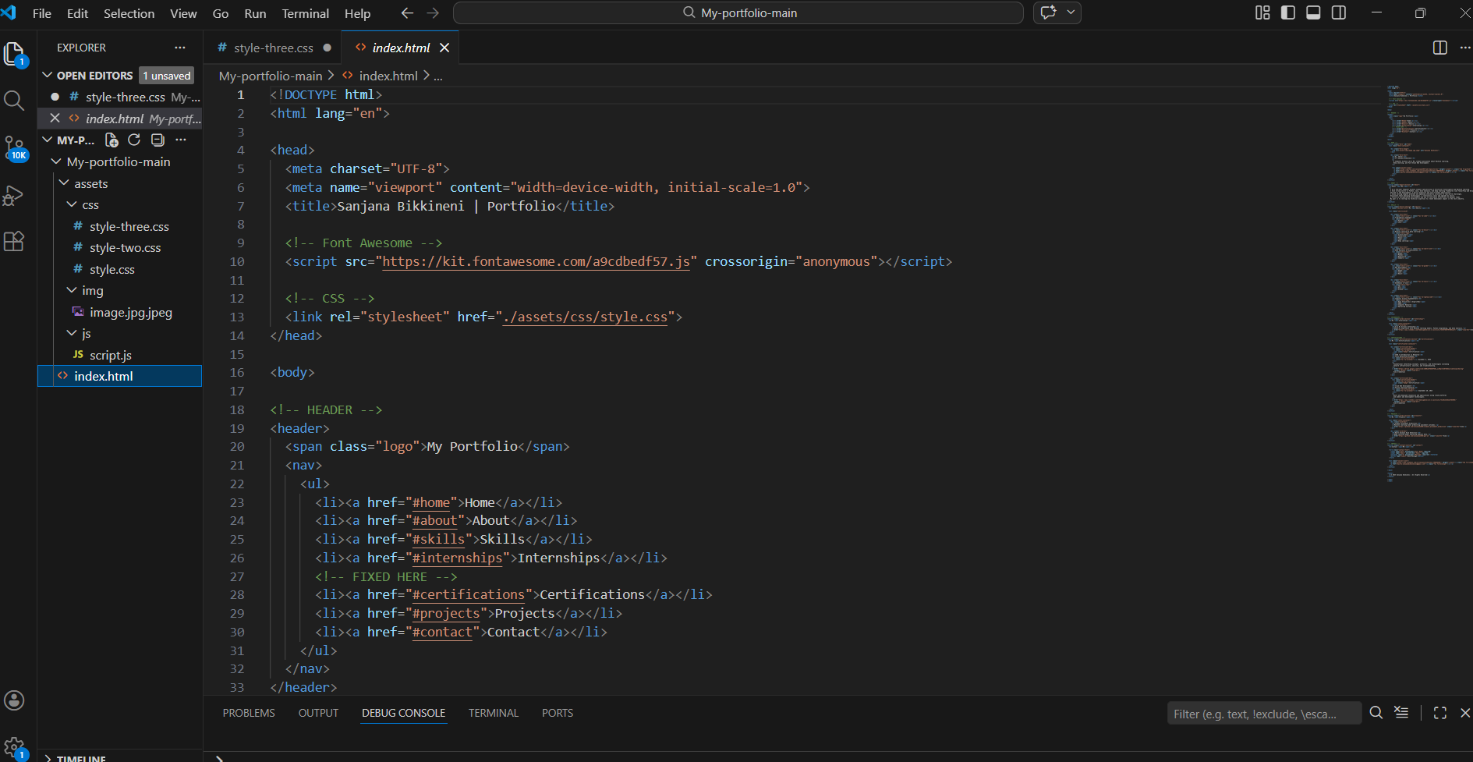

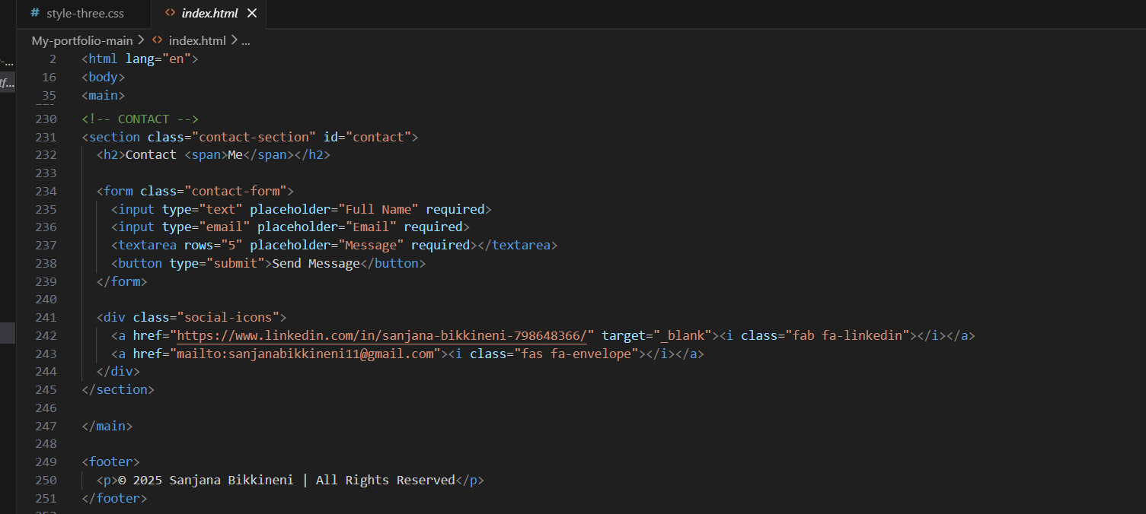

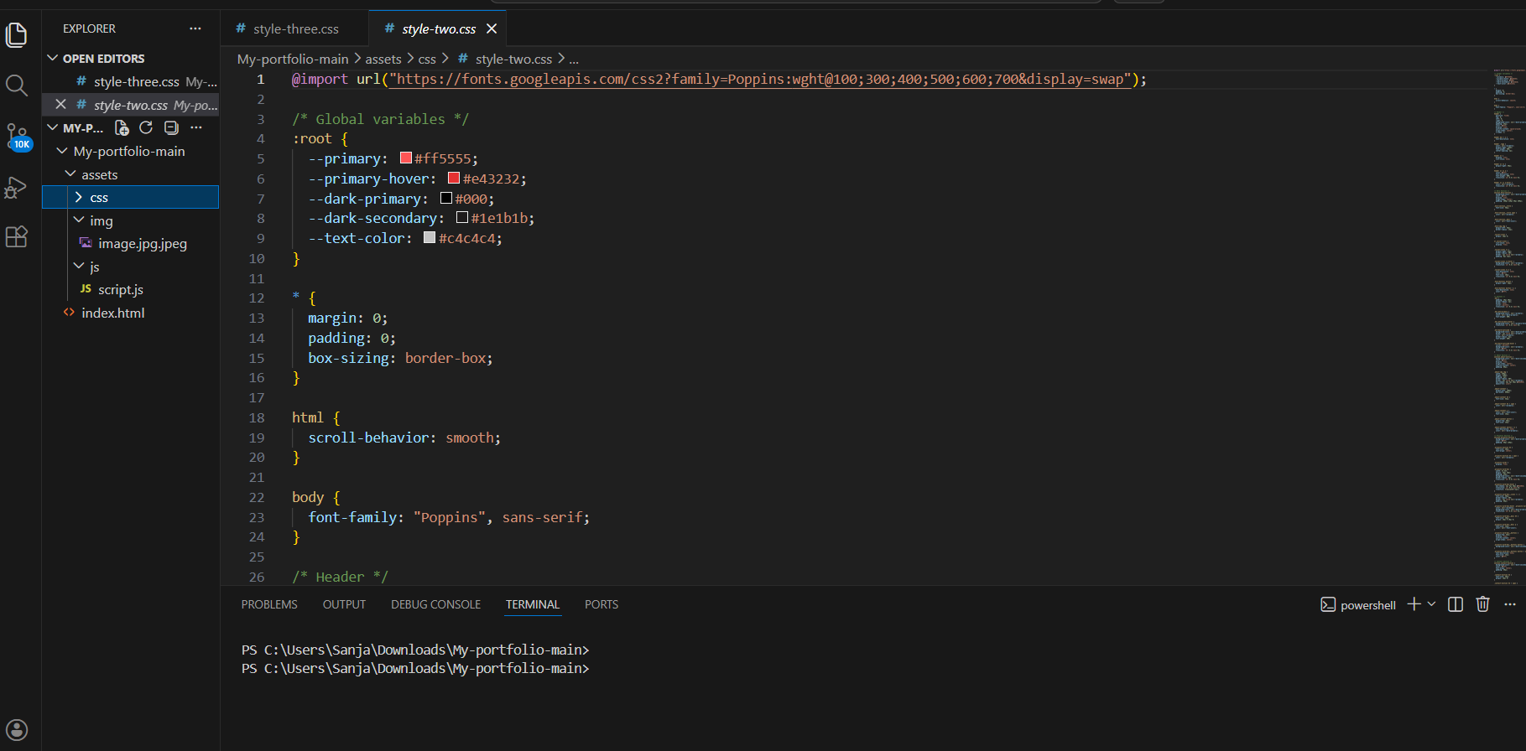

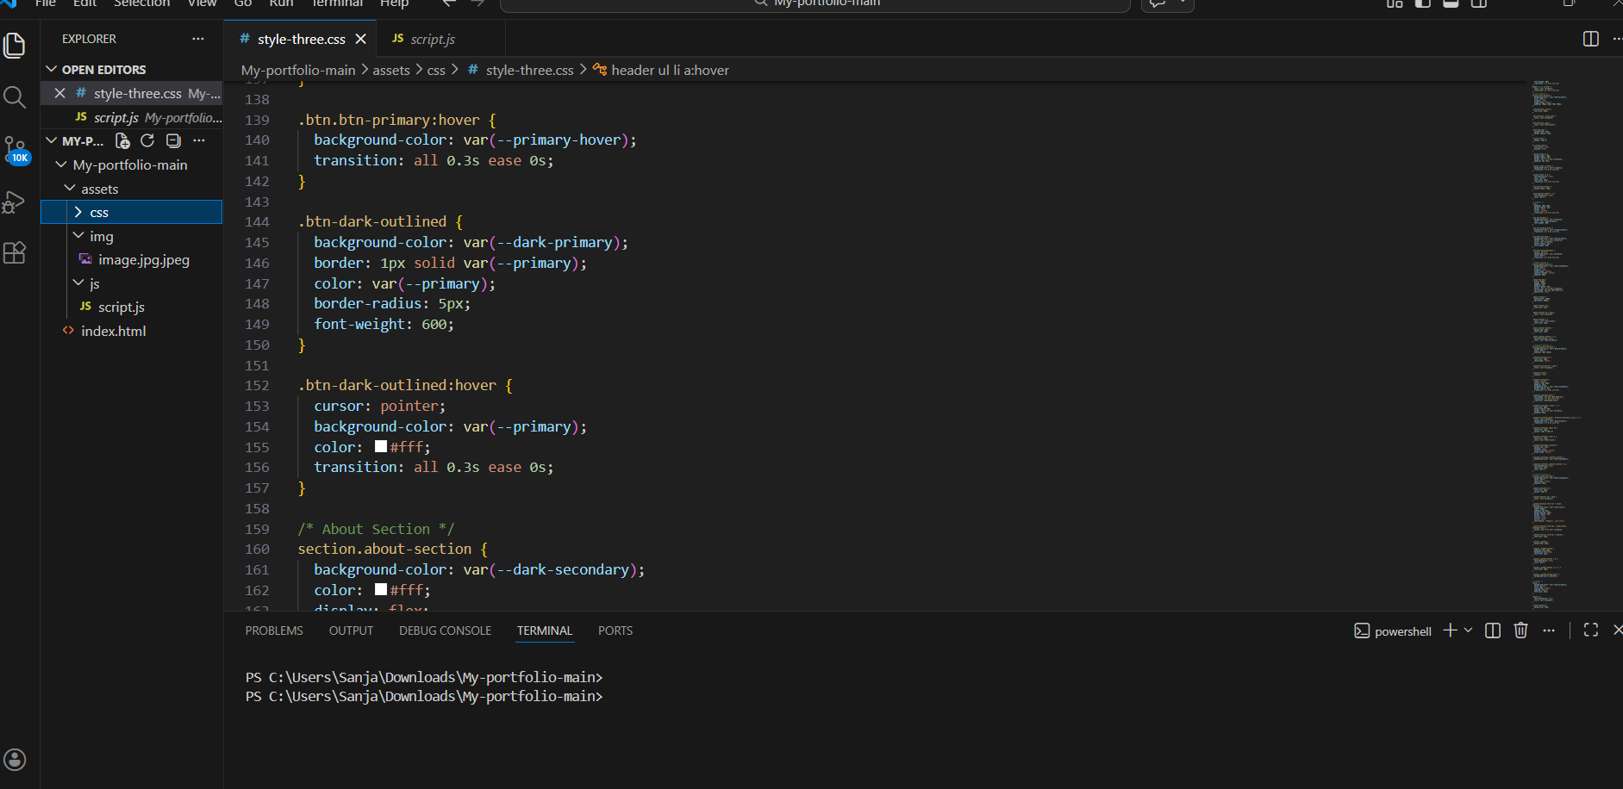

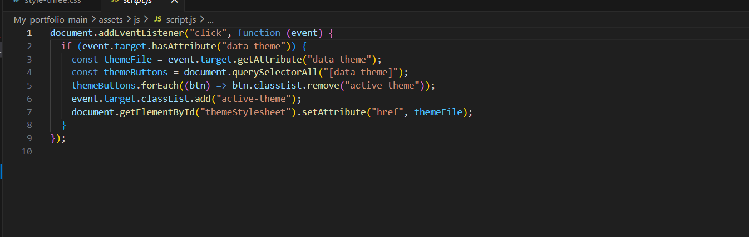
Output:
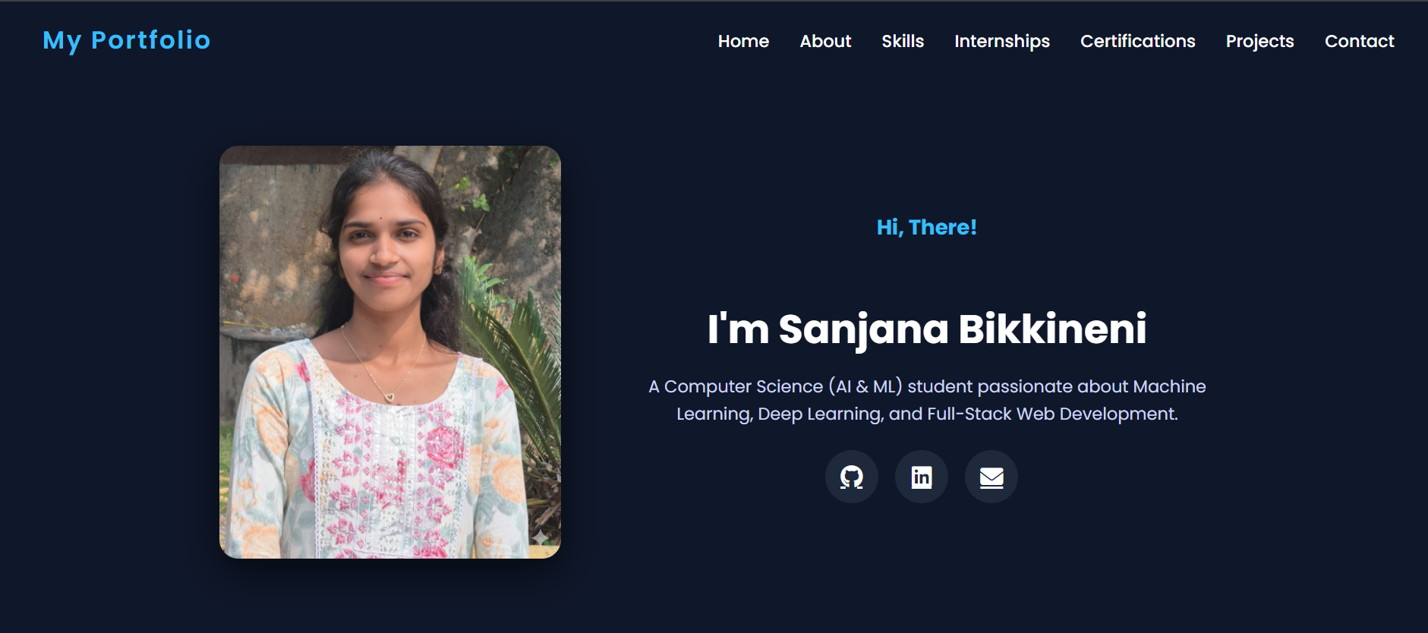
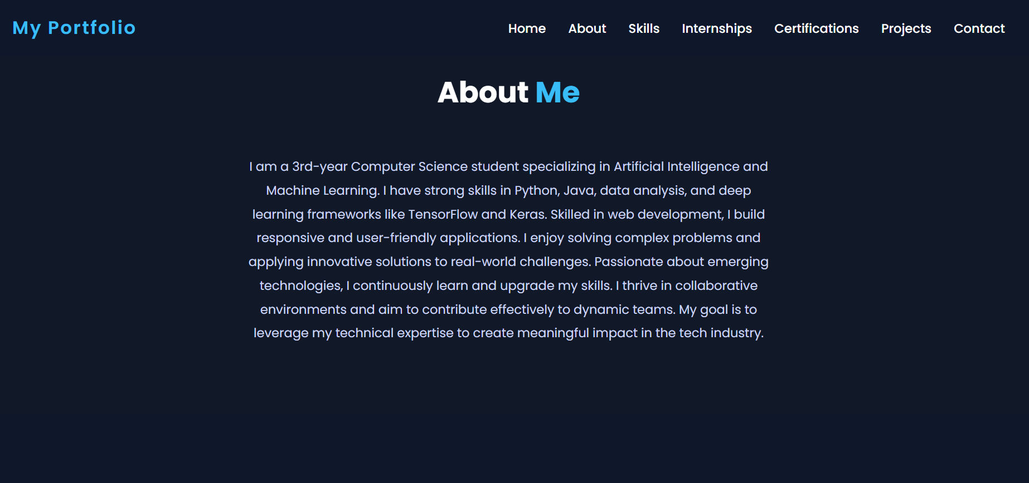
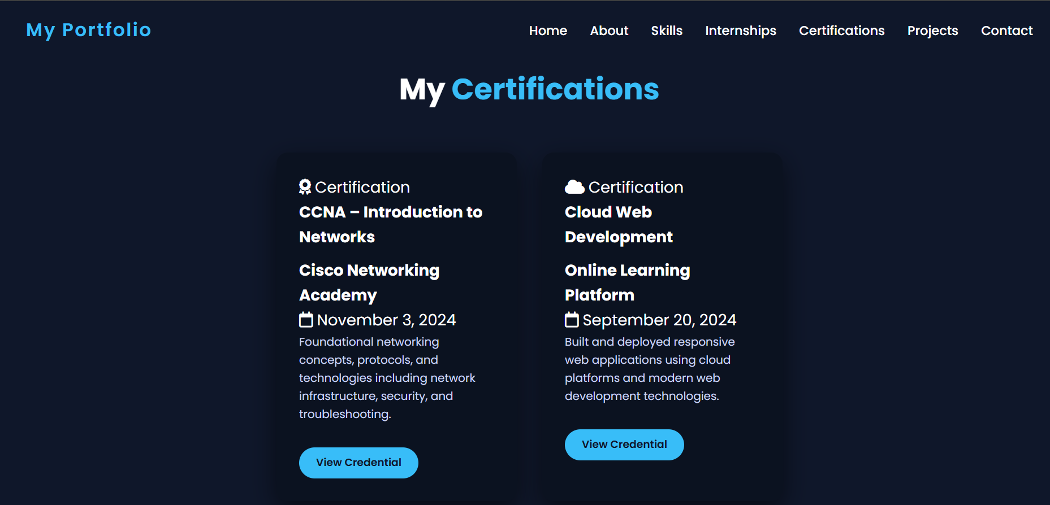
Observation:
The portfolio website was developed using HTML, CSS, and JavaScript with a clean and well-organized structure.
It includes clear sections for About Me, Projects, and Contact to improve navigation.
CSS was used to create a consistent color palette, typography, and responsive layout using Flexbox/Grid.
JavaScript was implemented to enable smooth scrolling navigation for a better user experience.
Overall, the website is simple, responsive, and effectively showcases my work.
Task2: Online Store Product Page
Prompt
Design a responsive product page using HTML, CSS, and JavaScript displaying image, title, price, and an “Add to Cart” button.
Use BEM methodology for structured and reusable CSS styling with hover effects.
Add JavaScript functionality to show an alert when the “Add to Cart” button is clicked.
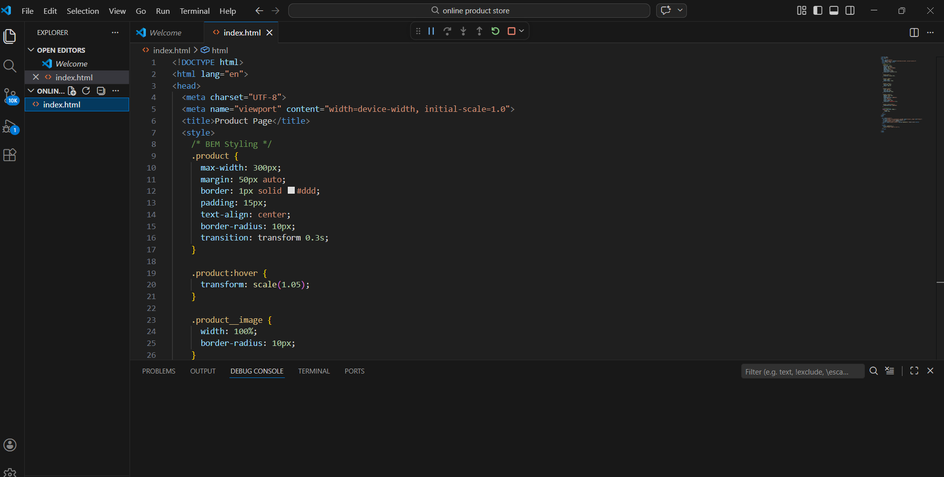
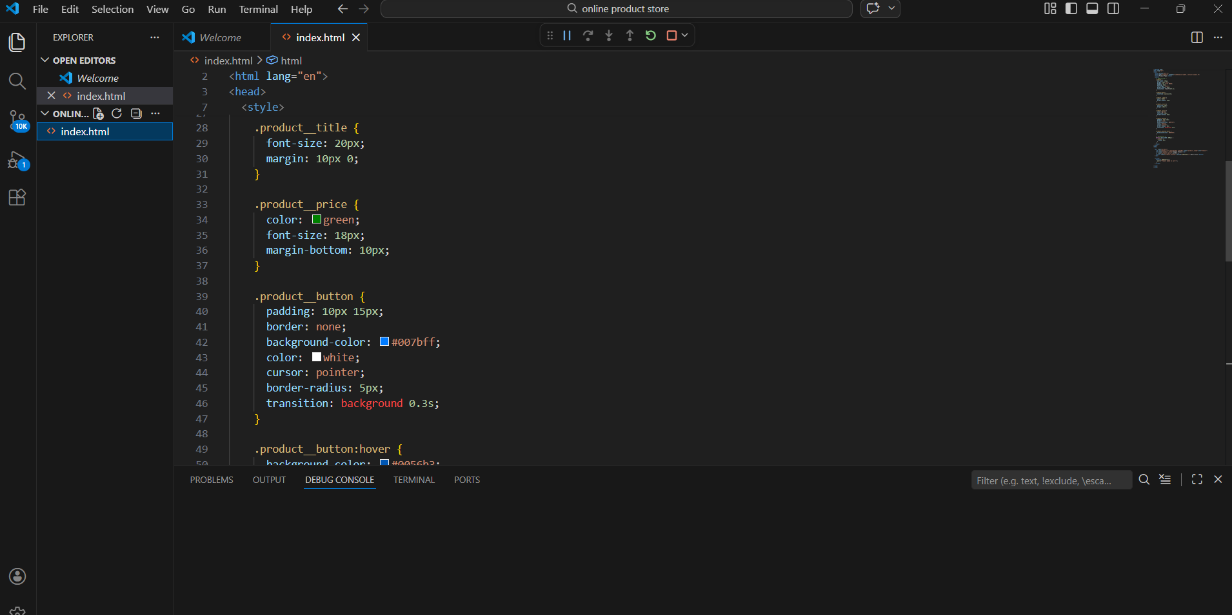
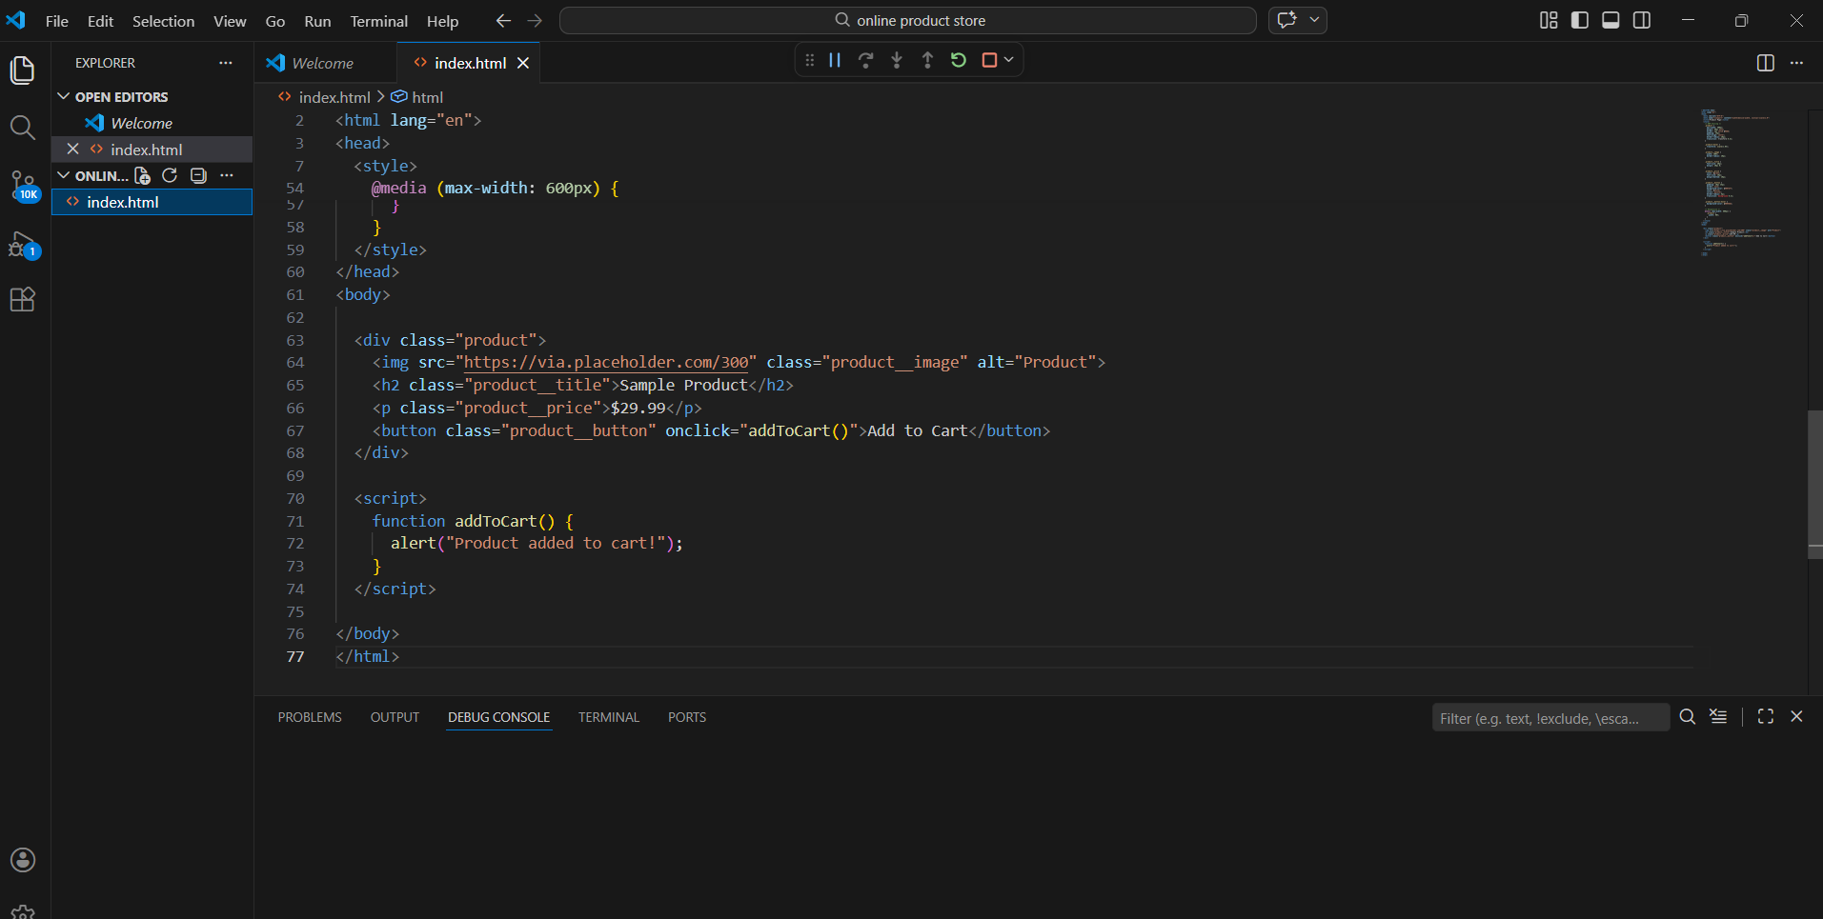
Output:
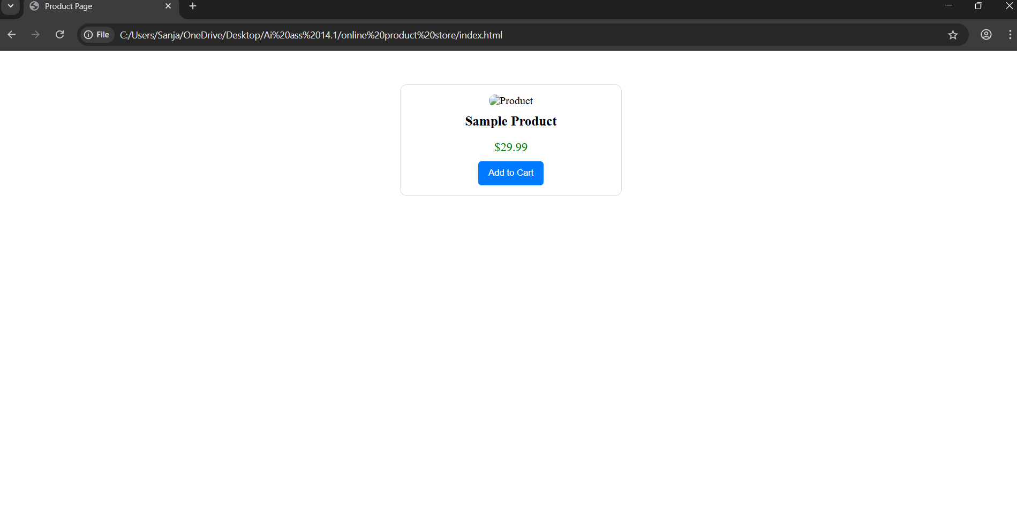
Observation:
The product page is designed using HTML, CSS, and JavaScript with a clean and structured layout.
BEM methodology ensures organized and reusable class naming, and the layout is responsive across devices.
Hover effects and the “Add to Cart” alert improve user interaction, making the page simple and user-friendly.

Task3: Event Registration Form
Prompt:
Create an event registration form using HTML, CSS, and JavaScript with fields for name, email, phone, and session selection.
Add JavaScript validation to ensure all inputs are correctly filled before submission.
Style the form professionally and include proper labels and ARIA attributes for accessibility.
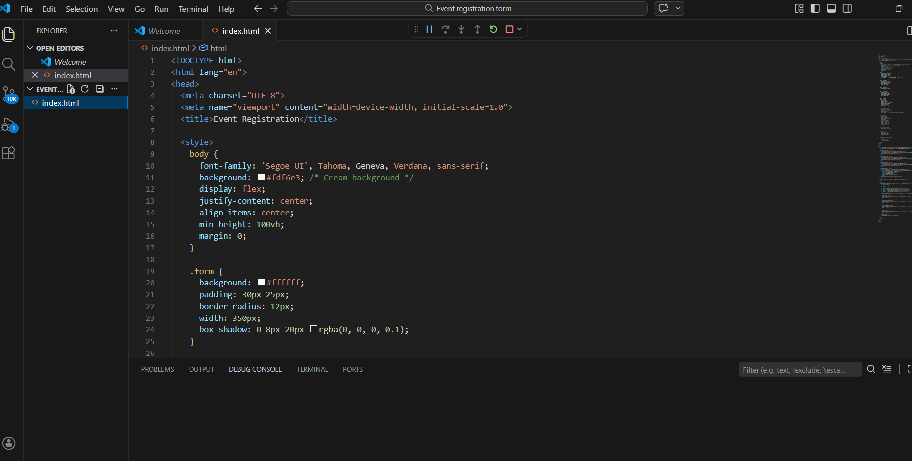
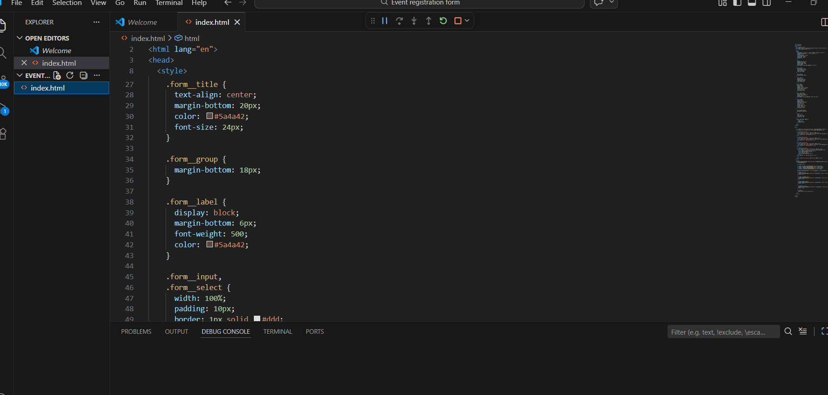
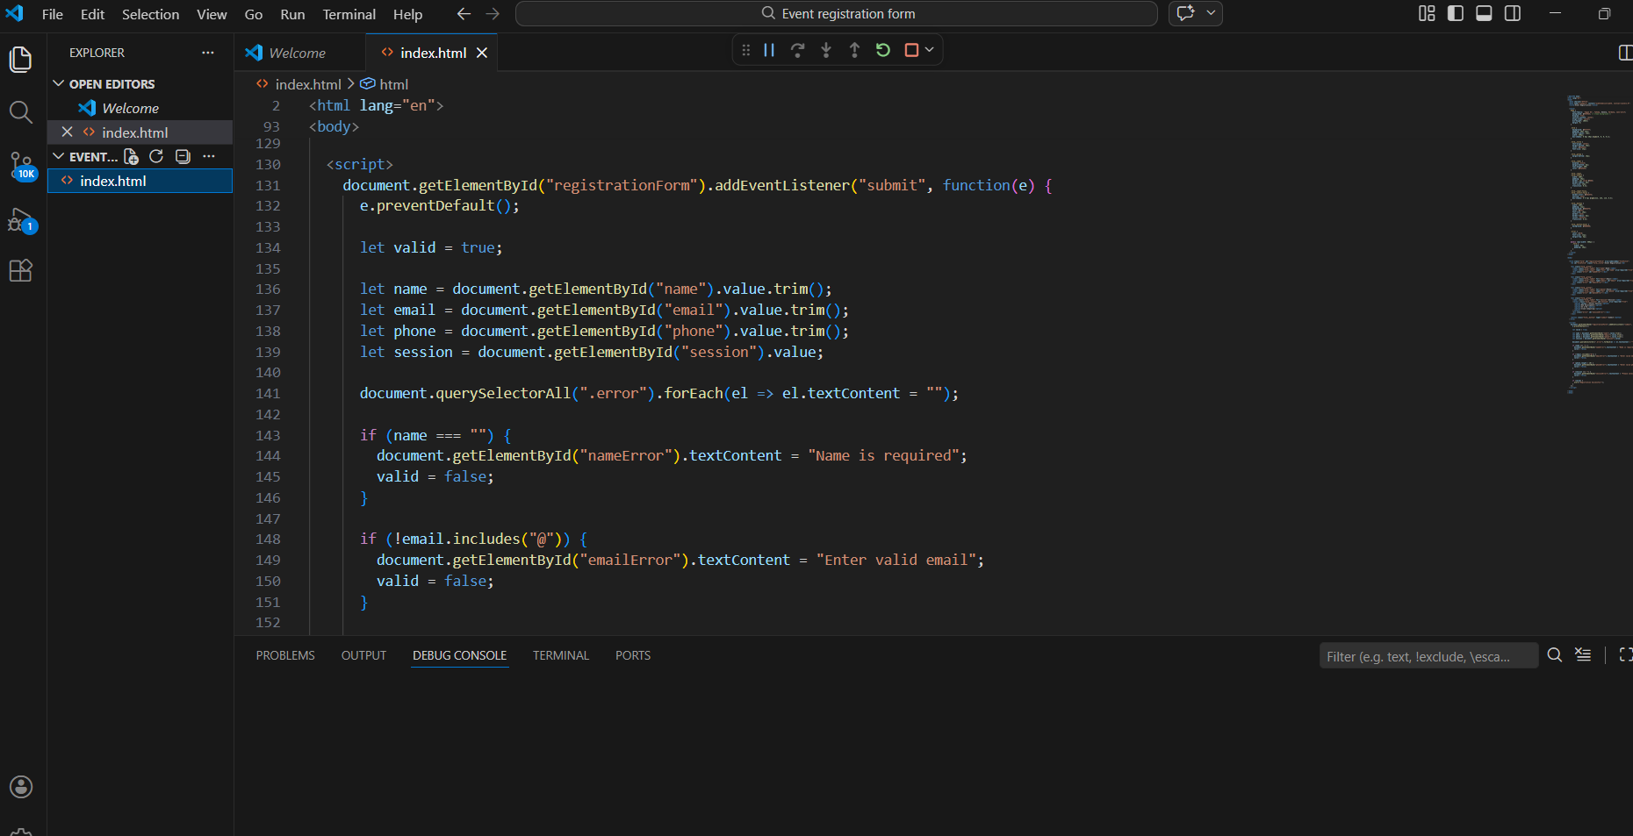
Output:
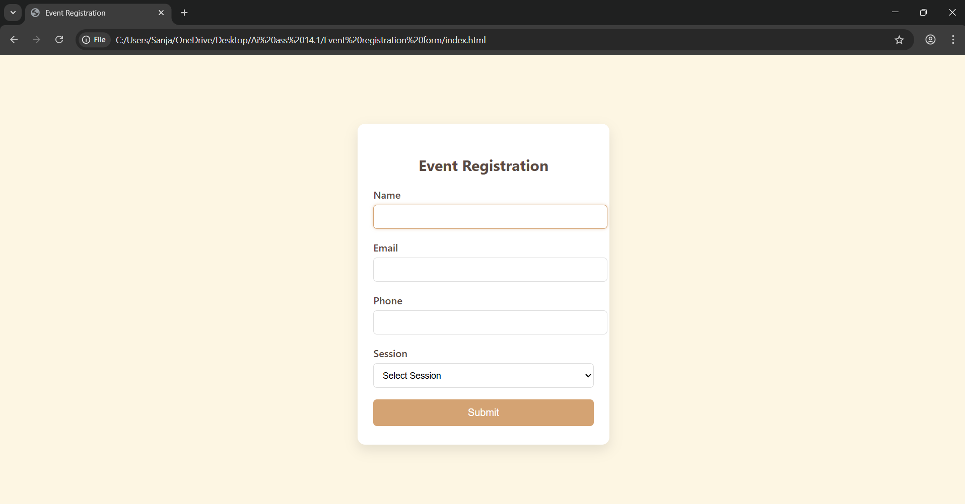
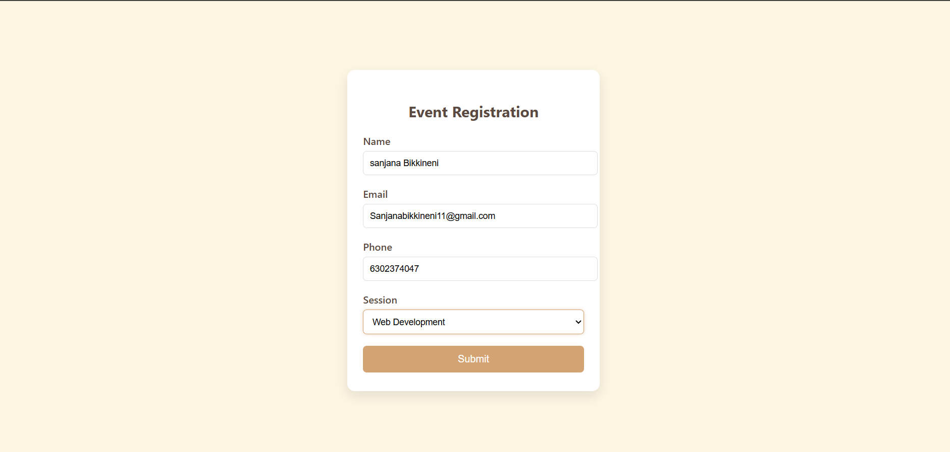
Observation:
The event registration form is built using HTML, CSS, and JavaScript with a clean and professional design.
Form validation ensures correct input, while labels and ARIA attributes improve accessibility.
The layout is user-friendly, responsive, and provides a smooth registration experience.
Task4: Resume Website
Prompt:
Create a one-page resume website using HTML, CSS, and JavaScript with sections for Profile, Skills, Education, and Experience.
Use CSS Grid for layout, professional typography, and smooth scrolling navigation.
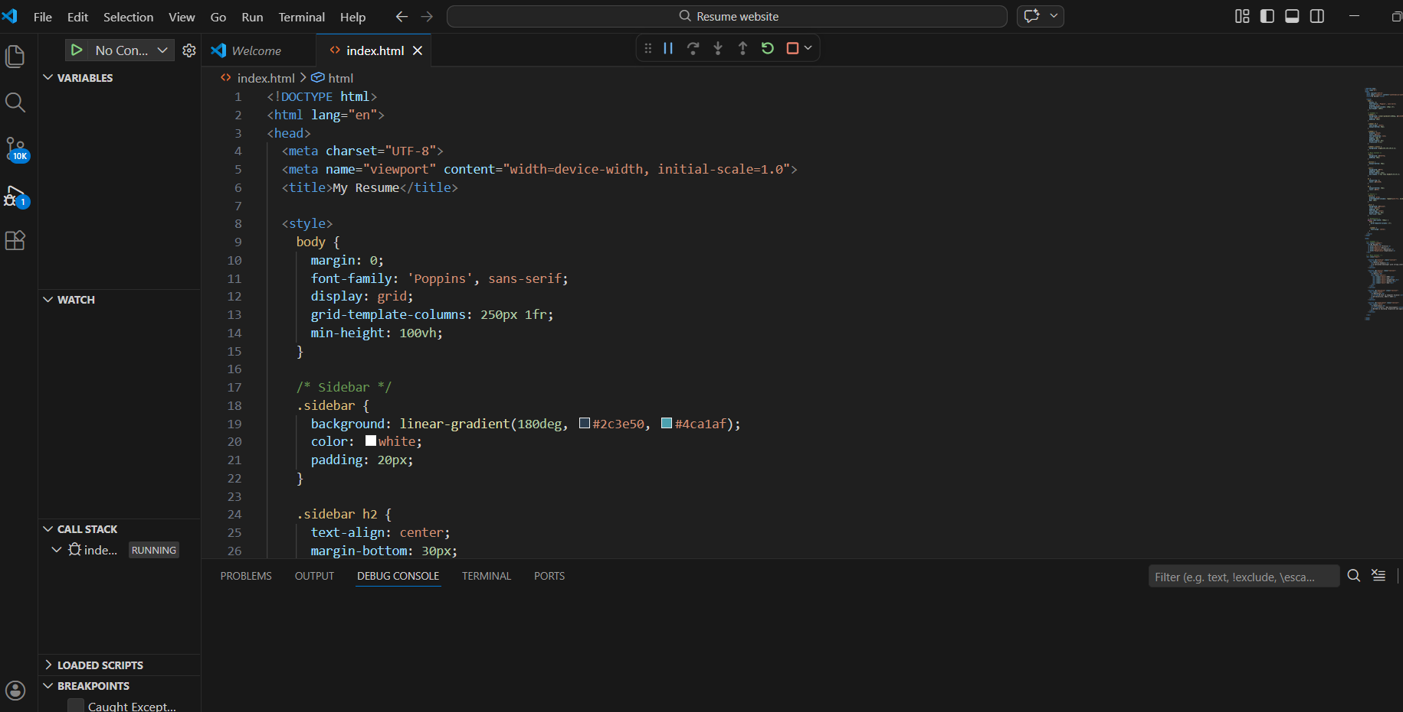
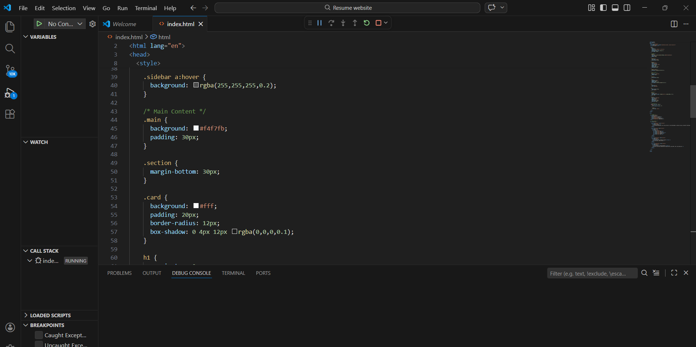
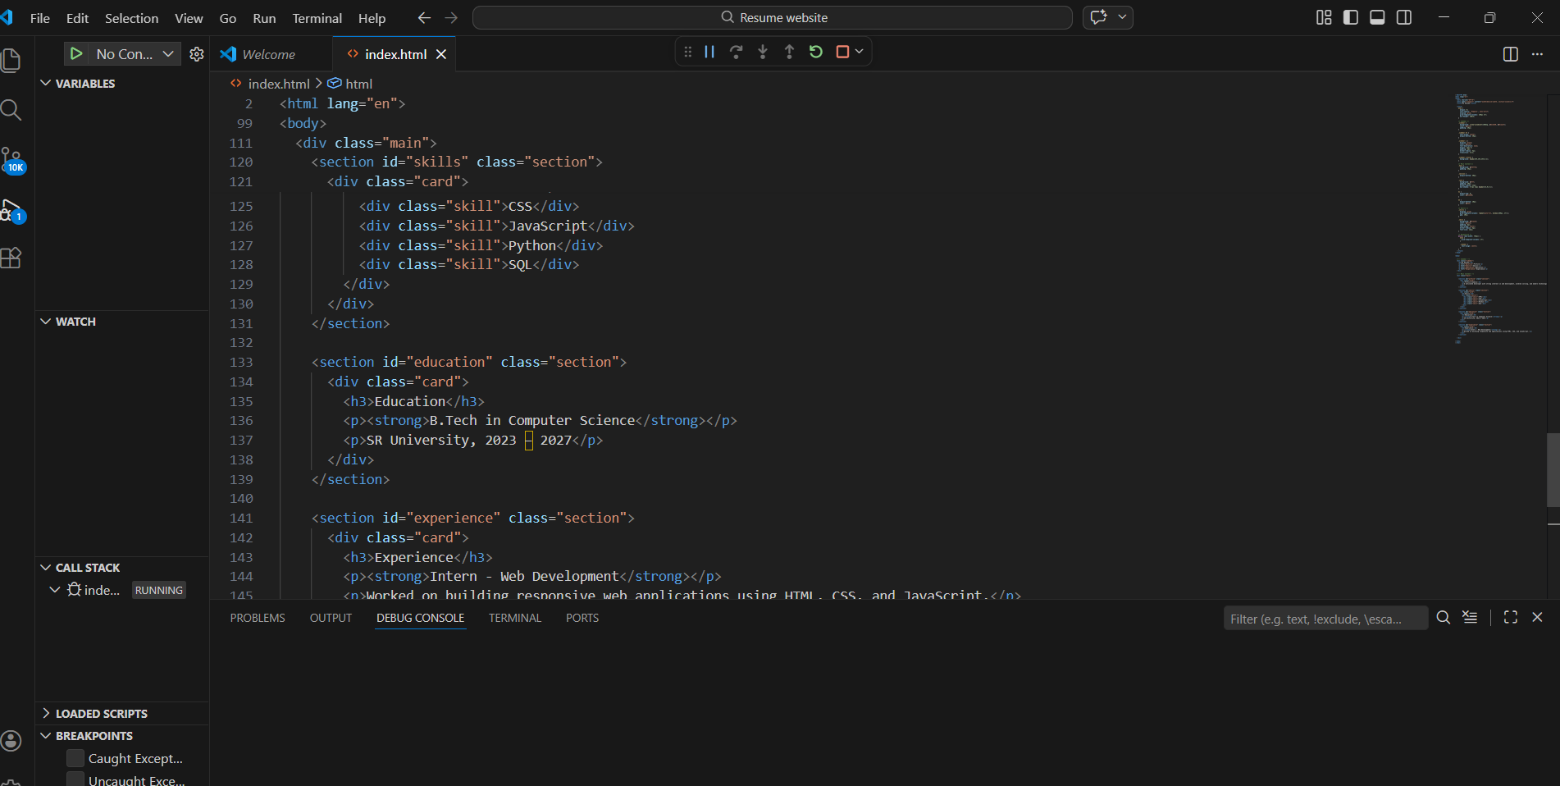
Output:
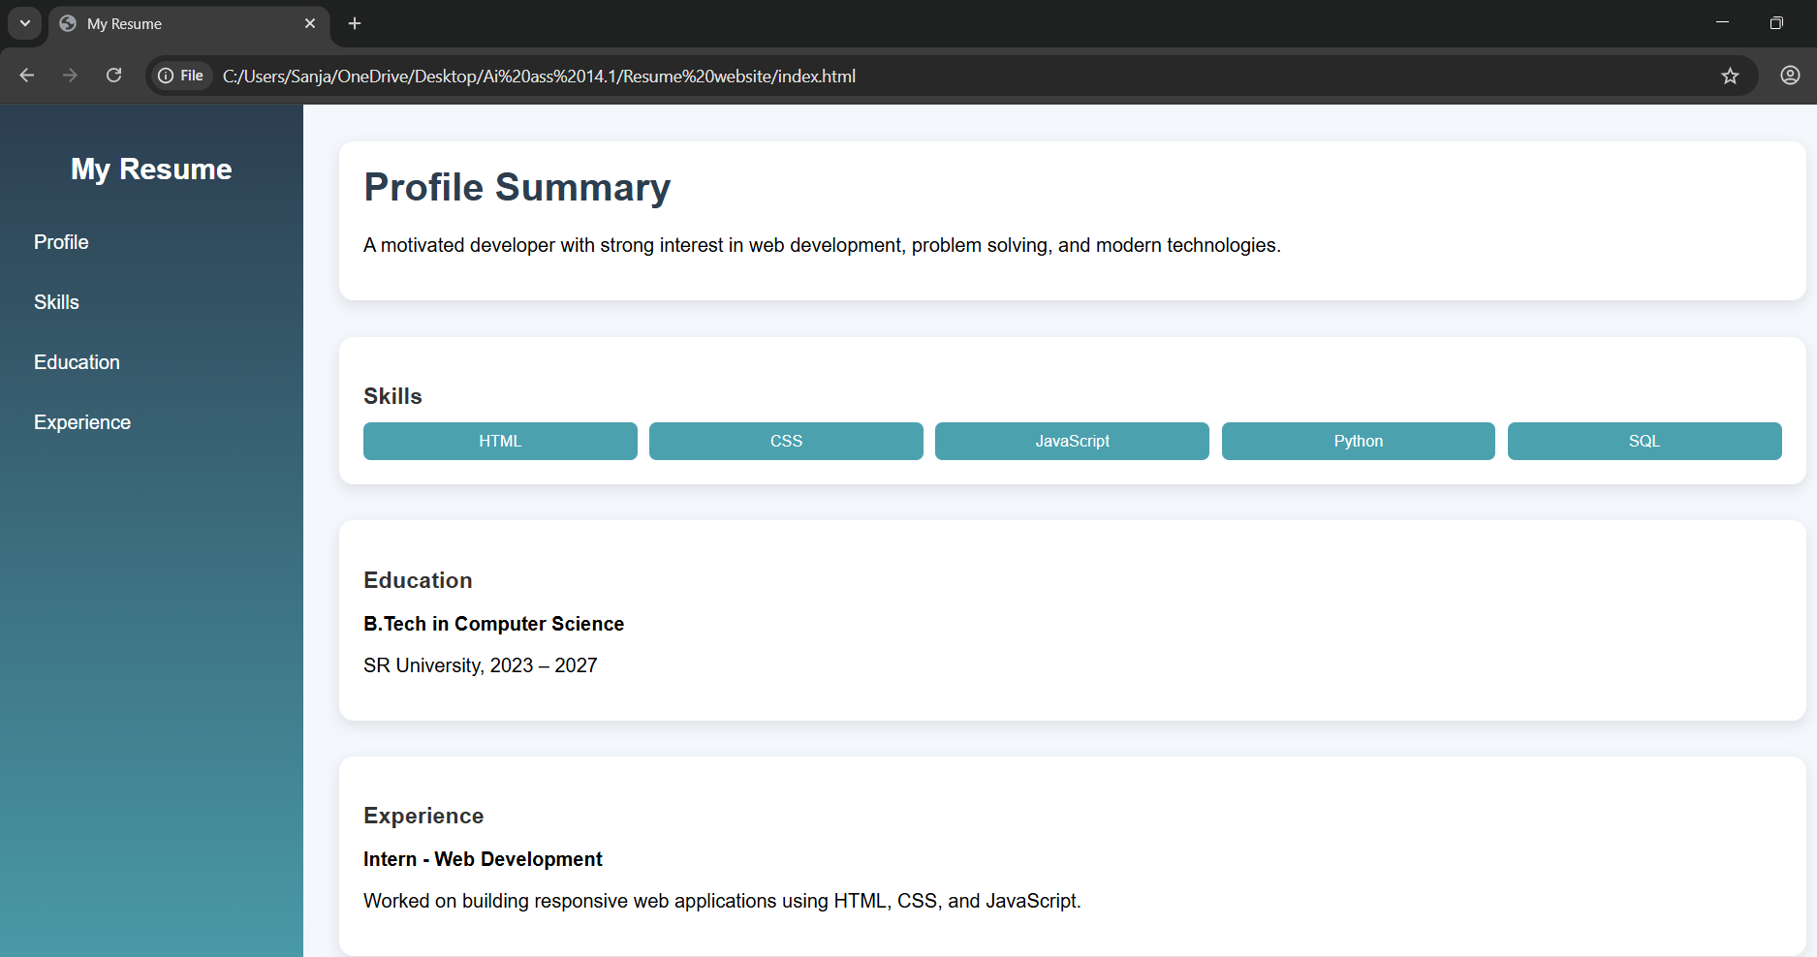
Observation:
The resume website uses a clean one-page layout with well-structured sections and professional typography.
CSS Grid and smooth scrolling enhance responsiveness, alignment, and overall user experience.
Task5: Restaurant Menu Page
Prompt:
Design a restaurant menu page using HTML and CSS displaying food name, description, and price in card layout.
Use a warm food-friendly color palette, responsive design, and add hover effects on menu items.
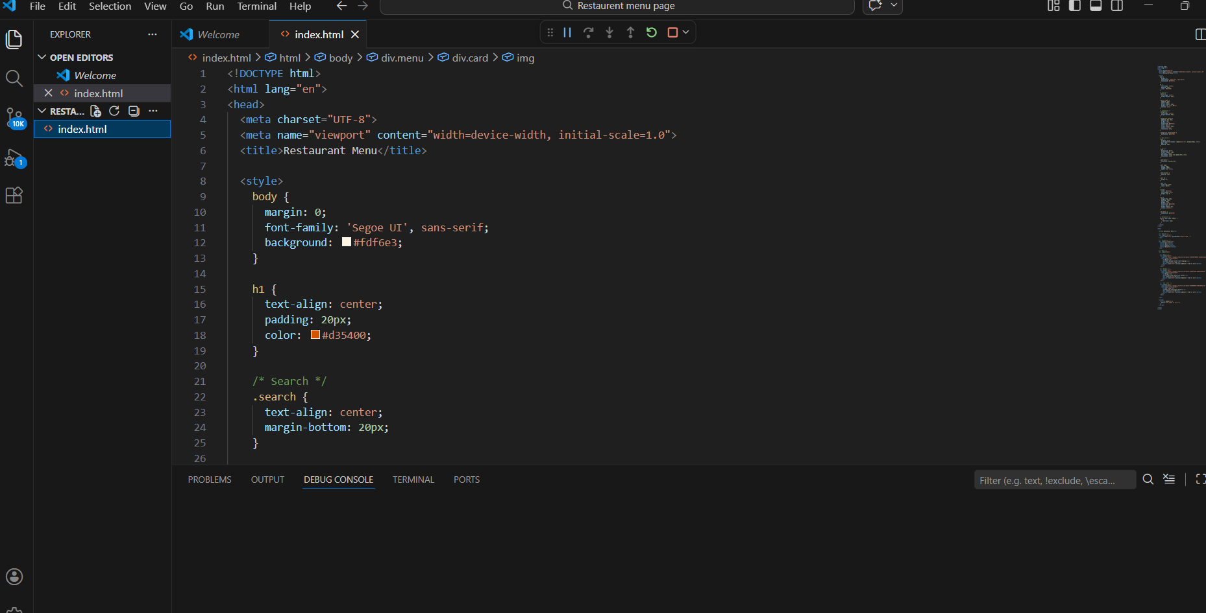

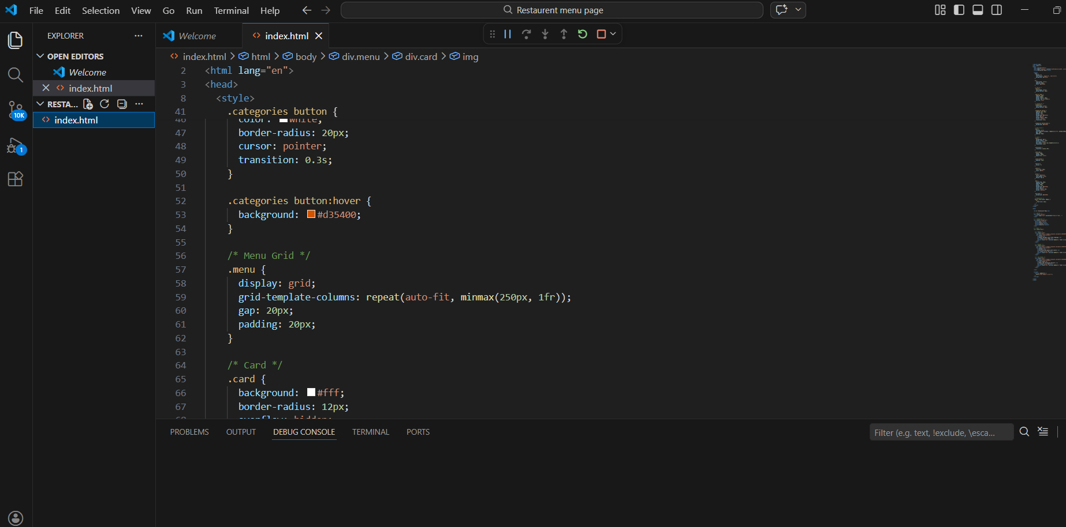

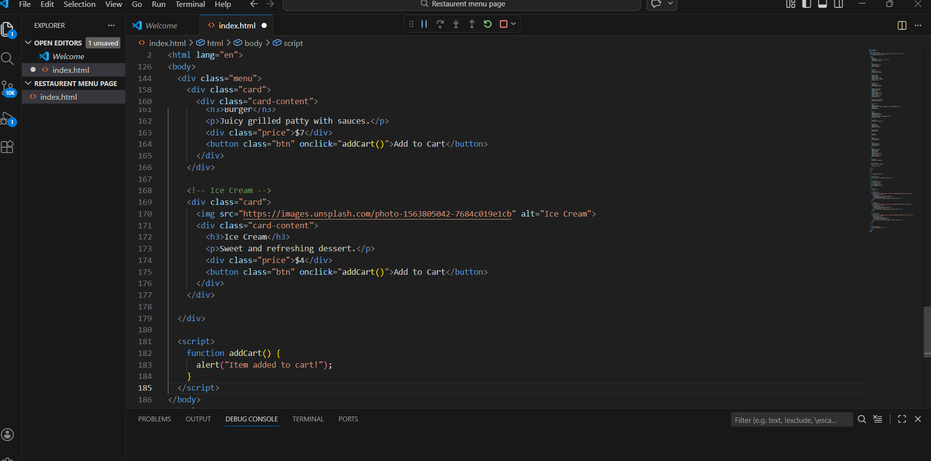Output: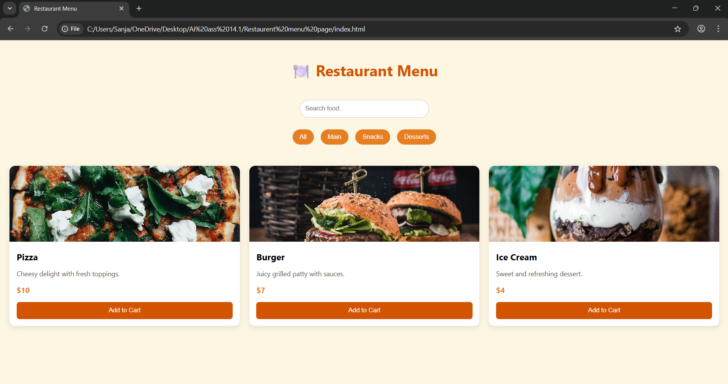
Observation:
The menu page uses a clean card-based layout with warm colors that enhance food appeal.
Responsive design and hover effects improve user interaction and browsing experience.

